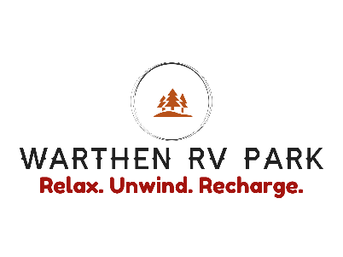
2022 SPONSORSHIP OPPORTUNITIES

It’s about that time for BBQ fans and music lovers to converge at Warthen RV Park for a day
of good eats, music, and family fun! We will shop, eat, drink, and interact with a variety of vendors.
Keep the little ones laughing and playing for hours in the Kids Zone—a family-friendly
playground and inflatable jumpers.
The festival features a 3 category BBQ cookoff and best sauce competition.
Over $1000 in cash and prizes will be awarded to contest winners. Huge crowds are expected with over 200 of your friends and neighbors.
Presenting Sponsor
• Presenting Sponsor in all facets of the ad campaign
• Company logo listed in all print material as Presenting Sponsor
• Included in social media campaign as Presenting Sponsor
• Inclusion in stage announcements as Presenting Sponsor
• Logo on T-shirt as Presenting Sponsor
• Opportunity to provide unlimited literature or promotional items in hospitality bags
• Logo and hyperlink on festival website - www.warthen-rv-park.com
INVESTMENT: Starting at $1,000
__________________________________________________________________________
Gold Sponsor
• Company logo listed in all print material
• Included in social media campaign
• Inclusion in stage announcements
• Logo on T-shirt as Gold Sponsor
• Opportunity to provide literature or promotional items in hospitality bags
• Logo and hyperlink on festival website - www.warthen-rv-park.com
INVESTMENT: $500
__________________________________________________________________________
Silver Level
• Included in social media campaign
• Logo on T-shirt as Silver Sponsor
• Opportunity to provide literature or promotional items in hospitality bags
• Logo and hyperlink on festival website - www.warthen-rv-park.com
INVESTMENT: $250
__________________________________________________________________________
Bronze Level
• Logo on T-shirt
• Opportunity to provide literature or promotional items in hospitality bags
• Logo and hyperlink on festival website - www.warthen-rv-park.com
INVESTMENT: $100
__________________________________________________________________________

